3-4-5 Year Old Beginner Lessons
Water Acclimation:
Lightly sprinkle or splash water on the child to build comfort.
- Practice bubbling:
  - Inhale deeply, exhale through mouth into water.
  - Repeat using nose for bubbles.
- Let the child hold your arms; if highly anxious, offer shoulder support only.
- Gently walk them a few yards into the water, wetting their mouth gradually.
- Repeat the movement 10 yards out with increased speed and water contact.
Kick & Float Development:
- Practice front kick with straight legs, offering support if needed.
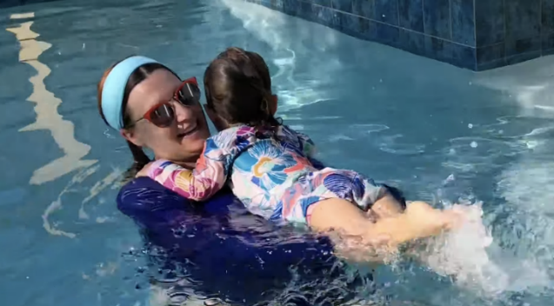
- Introduce back float with head and back support.
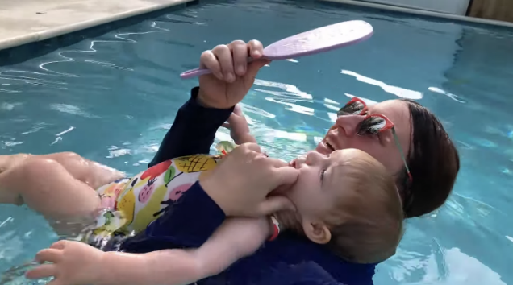
- Practice back float kick with straight legs, then guide independent kicking.
- Take them farther out for a full head dunk to boost confidence.
- Transition to independent front and back kicks.
- Finish with Bubbles or Water Splashes

